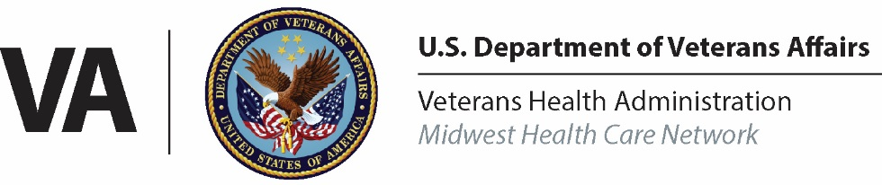 | News Release
FOR IMMEDIATE RELEASE  22 Feb 2019 |  | CONTACT:  André Kok, Public Affairs Officer  2805 Dodd Road, Suite 250  Eagan, Minnesota 55121  651-405-5635  Andre.Kok@va.gov

New Chief Medical Officer Named for VA Midwest Health
Care Network

EAGAN, Minn. — The Department of Veterans Affairs (VA) is pleased to announce the appointment of Dr. John A. Smyrski III as the new Chief Medical Officer of the VA Midwest Health Care Network.

“We are excited to bring Dr. Smyrski on board as Chief Medical Officer for the VA Midwest Health Care Network,” said network director, Mr. Robert McDivitt. “His sound leadership qualities and proven experience will be valuable assets to the health care system, employees, volunteers, and most importantly, to the Veterans we are honored to serve.”

Dr. Smyrski has over 33 years of clinical, operational and strategic leadership experience in healthcare delivery, research, acquisition, and human resources. He earned a Bachelor of Science degree in Natural Science from Saint John’s University, Collegeville, MN. A Distinguished Military Graduate, he received a Regular Army commission as a Second Lieutenant in the Aviation Branch. Most recently, he served as Chief, Health Services Division, US Army Human Resources Command at Fort Knox, KY. Dr. Smyrski holds a Doctor of Medicine degree from Uniformed Services University, a Master of Public Health degree from The University of Alabama at Birmingham, a Master of Business Administration degree from Troy University, and a Master of Strategic Studies degree from the US Army War College.

Dr. Smyrski is a Fellow, Aerospace Medical Association, a member of the Army Aviation Association of America’s (AAAA) Order of Saint Michael (Bronze and Silver Awards) and the Army Medical Department’s Order of Military Medical Merit. He is a member of Delta Omega Honorary Society in Public Health and Society of US Army Flight Surgeons Order of Aeromedical Merit. He also holds the prestigious Army Medical Department “A” Proficiency Designator and is a two time recipient (2004, 2014) of the AAAA Aviation Medicine Award for Army Flight Surgeon of the Year.

The VA Midwest Health Care Network serves more than 440,000 enrolled Veterans residing in the states of Iowa, Minnesota, Nebraska, North Dakota, South Dakota and portions of Illinois, Kansas, Missouri, Wisconsin and Wyoming. Health care services are delivered through an integrated system of 9 hospitals, 69 community based outpatient or outreach clinics, 8 community living centers and 4 domiciliary residential rehabilitation treatment programs.

###

